Семинар Лаборатории Алгебраической геометрии и ее приложений
Семинар состоится в пятницу 24 февраля 2017 года.
Начало в 17:00.
Семинар будет проходить по адресу: ул. Усачева, д.6, аудитория 306

На семинаре выступит Федор Богомолов  (Courant Institute, ВШЭ) с докладом: | 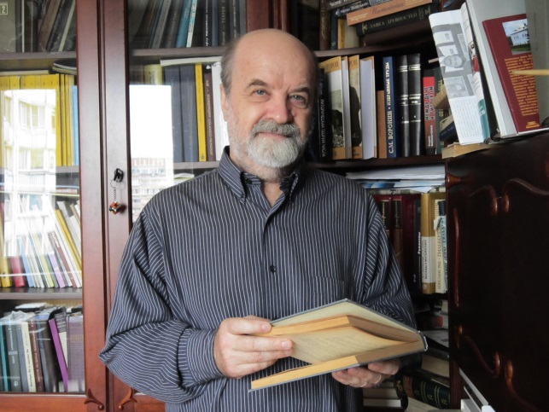
Geometry of sets of torsion points on elliptic curves

Abstract: In this talk I introduce and discuss geometry of curves parametrizing subset of points in $P^1$ obtained as projections of torsion points of elliptic curves. For every subset of different $k$ points in $P^1$ we can define it's image in the moduli $M_{0,k}$ of $k$-tuples of points which is essentially a quotient of projective space $S^kP^1= P^k$ by the action of $PGL(2)$. Thus $M_{0,k}$ is a rational variety of dimension $k-3$. If we consider the images of points of finite order in different elliptic curves under natural projections then we obtain an (infinite) system of modular typoe curves with maps into $M_{0,k}$ I will formulate
three conjectures (semi theorems) about properties of such maps which provide a possiblity of realistic universal estimate for intersections between subset of torsion points for different elliptic curves.

Приглашаются все желающие!

