Семинар Лаборатории Алгебраической геометрии и ее приложений
Семинар состоится в пятницу 21 апреля 2017 года.
Начало в 17:00.
Семинар будет проходить по адресу: ул. Усачева, д.6, аудитория 306

На семинаре выступит Pavel Safronov (Geneva) | 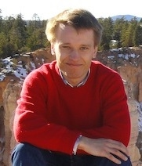
с докладом:

Introduction to derived Poisson geometry with examples

Abstract: Derived Poisson geometry studies higher Poisson structures on (derived) algebraic stacks. I will explain what higher Poisson structures are and how to define them on stacks
following the work of Calaque, Pantev, Toen, Vaqui'e and Vezzosi. Moreover, one can define an interesting generalization of the notion of a coisotropic submanifold in this context which I will describe following joint work with Melani. In the second half of the talk I will give several examples of these constructions some of which come from Poisson-Lie groups..

Приглашаются все желающие!

