Семинар Лаборатории Алгебраической геометрии и ее приложений
Семинар состоится в пятницу 18 августа 2017 года.
Начало в 17:00.
Семинар будет проходить по адресу: ул. Усачева, д.6, аудитория 306

На семинаре выступит Федор Богомолов  (Courant Institute, ВШЭ) с докладом: | 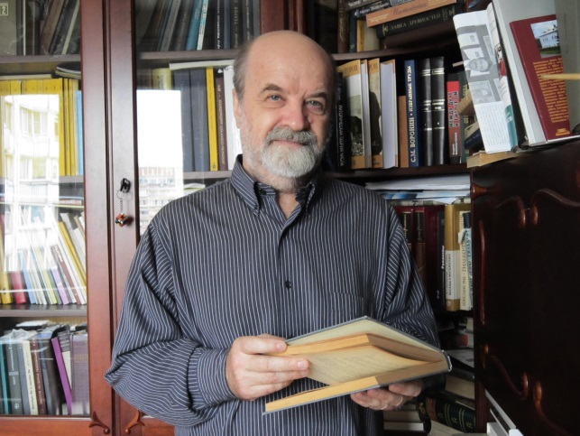
$PGL(2)$-invariants of collections of torsion points of elliptic curves

Abstract: In this talk I will continue to discuss geometry of sets of images of torsion points of elliptic curves in $P^1$. I am going to develop some ideas which were mentioned in my previous talks on the subject. In particular I provide an argument proving the first conjecture described in previous talk for almost all $4$ tuples of the images of torsion points.
I will repeat the main defintions and notations which were used in the previous talks.

Приглашаются все желающие!

