Семинар Лаборатории Алгебраической геометрии и ее приложений
Семинар состоится в пятницу 1 сентября 2017 года.
Начало в 17:00.
Семинар будет проходить по адресу: ул. Усачева, д.6, аудитория 306

На семинаре выступит  Андрей Солдатенков (University of Bonn) | 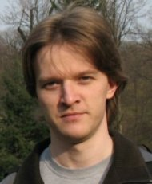
с докладом:
Kuga-Satake construction and its generalizations

Abstract: Let H be a rational polarized weight 2 Hodge structure of K3 type, meaning that the (2,0) component is one-dimensional. Classical Kuga-Satake construction attaches to it an abelian variety A an an embedding of H into the second cohomology of A, compatible with Hodge structures. I will talk about our recent work with N.Kurnosov and M.Verbitsky in which we consider the case where H is the second cohomology of a hyperkahler manifold X. We show that all cohomology of X can be embedded into the cohomology of the product of several copies of A. If time permits, I will talk about our joint work with S.Schreieder, where we consider the behaviour of Kuga-Satake abelian varieties under degeneration. It turns out that one can describe the limit mixed Hodge structure on the central fibre of degenerating
family of Kuga-Satake varieties.

Приглашаются все желающие!

