Внеочередной семинар Лаборатории Алгебраической геометрии и ее приложений
Семинар состоится в среду 4 октября 2017 года.
Начало в 18:30.
Семинар будет проходить по адресу: ул. Усачева, д.6, аудитория 306

На семинаре выступит

Jean-Louis Colliot-Thelene

(CNRS, Universite Paris-Sud Paris-Saclay)

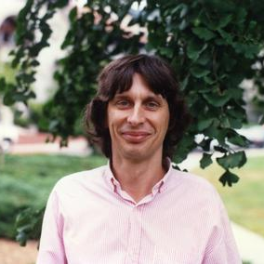
с докладом:
Disproving stable rationality

Abstract: In the last four years, a series of papers by several authors has established that some very classical, rationally connected, complex varieties (cyclic covers of projective space with ramification locus of low degree, hypersurfaces of low degree, quadric bundles over rational
varieties) are not stably birational to projective space. In the first part of the talk I shall give a general description of the method and of some of its variants, and I shall try to list the main results achieved. The second part of the talk will be devoted to a recent variant of the technique.

Приглашаются все желающие!

