Семинар Лаборатории Алгебраической геометрии и ее приложений совместно с Лабораторией зеркальной симметрии и автоморфных форм
Семинар состоится в пятницу 20 октября 2017 года.
Начало в 17:00.
Семинар будет проходить по адресу: ул. Усачева, д.6, аудитория 306

На семинаре выступит  Sergey Arkhipov (Aarhus University) | 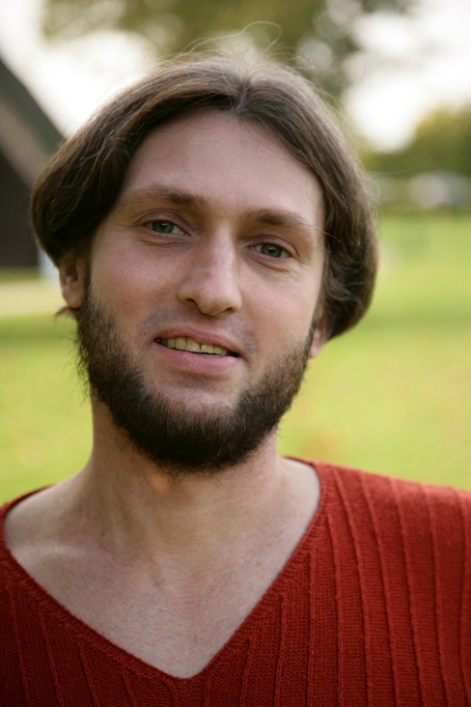
с докладом:

Braid relations in the affine Hecke category and differential forms with logarithmic singularities

Abstract: We recall the even and odd algebro-geometric realizations of the affine Hecke category - one via equivariant coherent sheaves on the Steinberg variety and the other in terms of some equivariant DG-modules over the DG-algebra of differential forms on a reductive group G.
The latter one has a toy analog called the coherent Hecke category. It contains certain canonical objects satisfying braid relations via convolution. The proof uses simple facts from the geometry of Bott-Samelson varieties.
Our goal is to provide a similar proof of braid relations in the affine Hecke category. It turns out that canonical braid group generators are given by certain DG-modules of logarithmic differential forms and braid relations follow immediately from a general statement which seems to be new: direct image of the DG-module of logarithmic differential forms does not depend on a resolution of
singularities.

Приглашаются все желающие!

